**CALCULUS APPLICATION**

**NOVEMBER 2008**

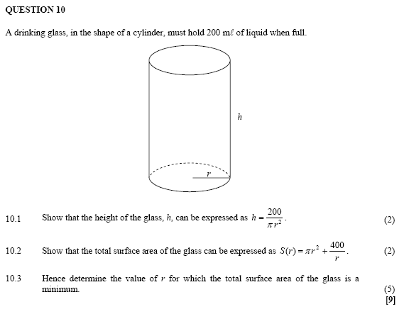

**FEB/MARCH 2009**

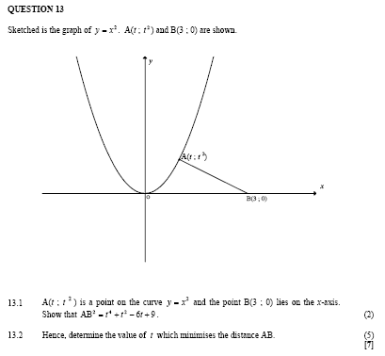

**NOVEMBER 2009**

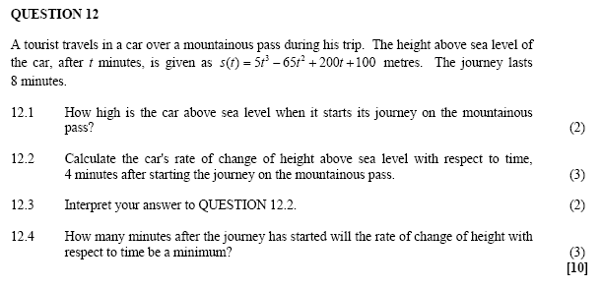

**FEB/MARCH 2010**

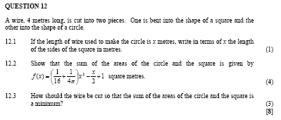

**NOVEMBER 2010**

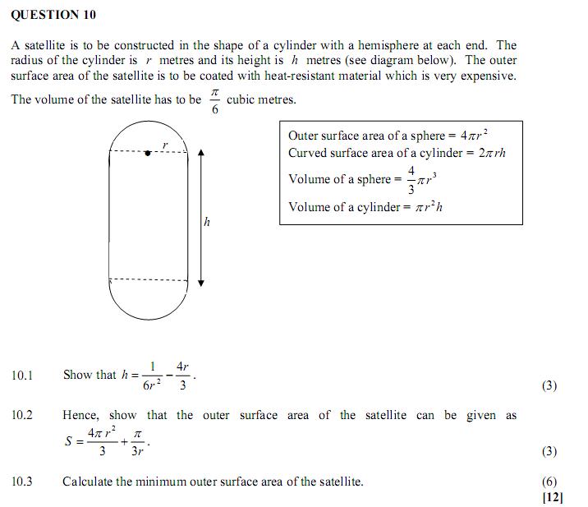

**FEB/MARCH 2011**

**QUESTION 11**

|  |  |  |
| --- | --- | --- |
| A farmer has a piece of land in the shape of a right-angled triangle OMN, as shown in the figure below. He allocates a rectangular piece of land PTOR to his daughter, giving her the freedom to choose P anywhere along the boundary MN. Let OM = *a*, ON = *b* and P(*x* ; *y*) be any point on MN. |  |  |

O

T

P(*x* ; *y*)

R

M (*a* ; 0)

N (0 ; *b*)



|  |  |  |  |
| --- | --- | --- | --- |
| 11.1 | Determine an equation of MN in terms of *a* and *b*. |  | (2) |

|  |  |  |  |
| --- | --- | --- | --- |
| 11.2 | Prove that the daughter's land will have a maximum area if she chooses P at the midpoint of MN. |  | (6)  **[8]** |

**NOVEMBER 2011**

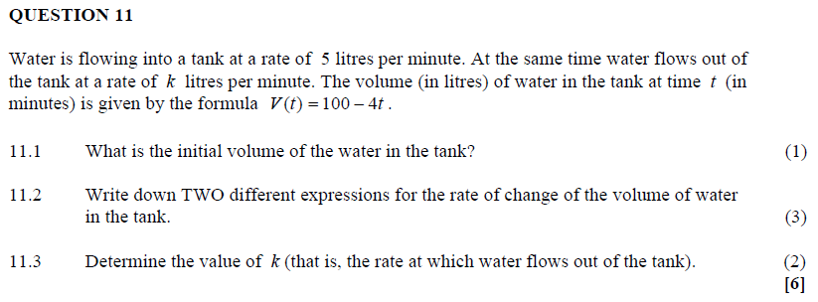

**FEBRUARY/MARCH 2012 NO QUESTION**

**NOVEMBER 2012**

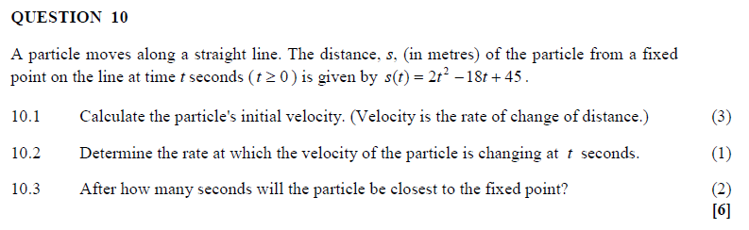

**MARCH 2013**

**QUESTION 11**

