**CALCULUS APPLICATION (3RD DEGREE GRAPHS)**

**NOVEMBER 2008 FEB/MARCH 2009**

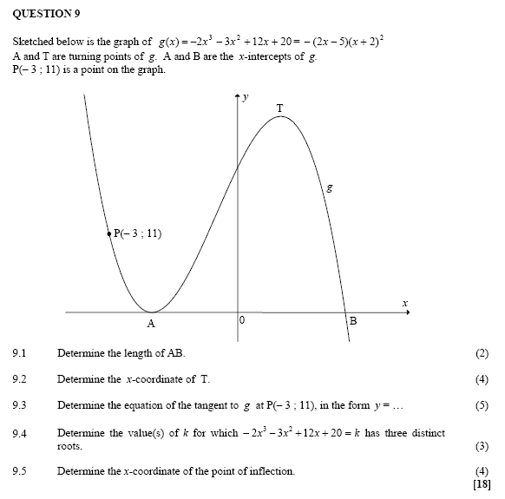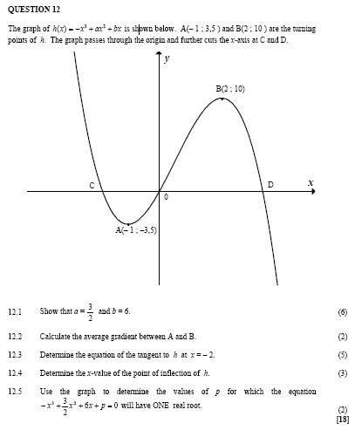

**NOVEMBER 2009**

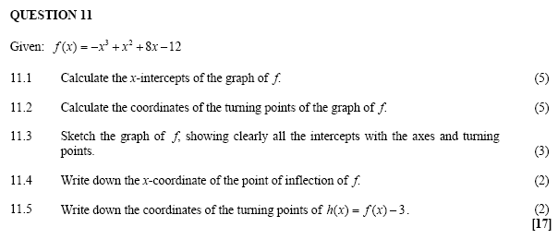

**FEB/MARCH 2010**

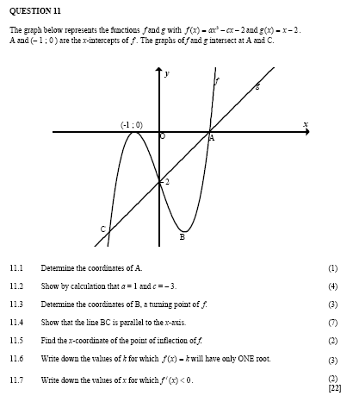

**NOVEMBER 2010**

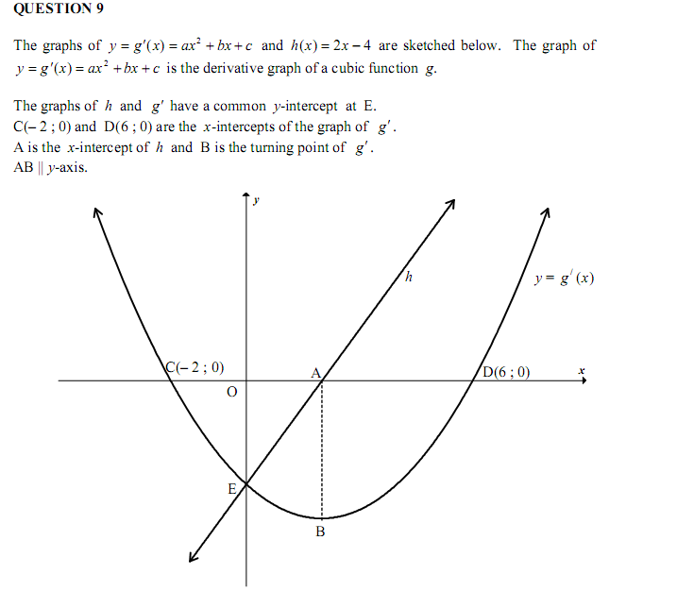 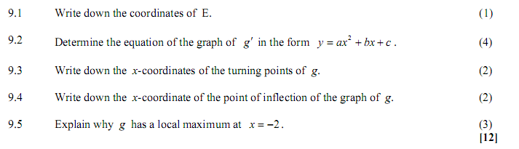

**FEB/MARCH 2011**

**QUESTION 10**

|  |  |  |
| --- | --- | --- |
| Given: |  |  |

|  |  |  |  |
| --- | --- | --- | --- |
| 10.1 | Calculate the *y*-intercept of *g*. |  | (1) |

|  |  |  |  |
| --- | --- | --- | --- |
| 10.2 | Write down the *x*-intercepts of *g*. |  | (2) |

|  |  |  |  |
| --- | --- | --- | --- |
| 10.3 | Determine the turning points of *g*. |  | (6) |

|  |  |  |  |
| --- | --- | --- | --- |
| 10.4 | Sketch the graph of *g* on DIAGRAM SHEET 2. |  | (4) |

|  |  |  |  |
| --- | --- | --- | --- |
| 10.5 | For which values of *x* is |  | (3)  **[16]** |

**NOVEMBER 2011**

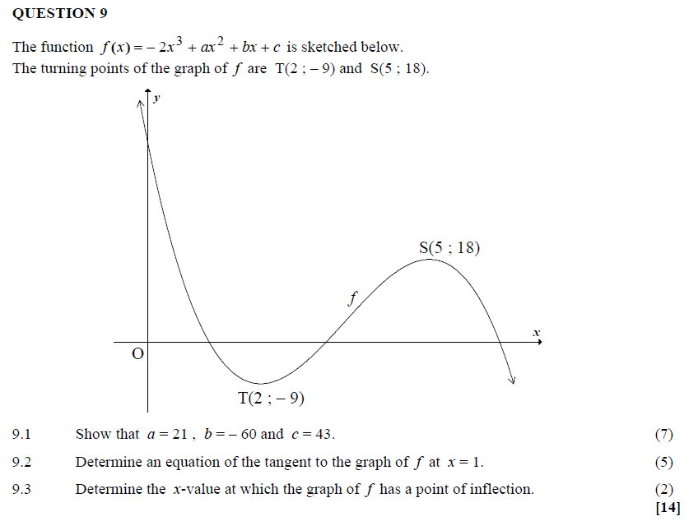

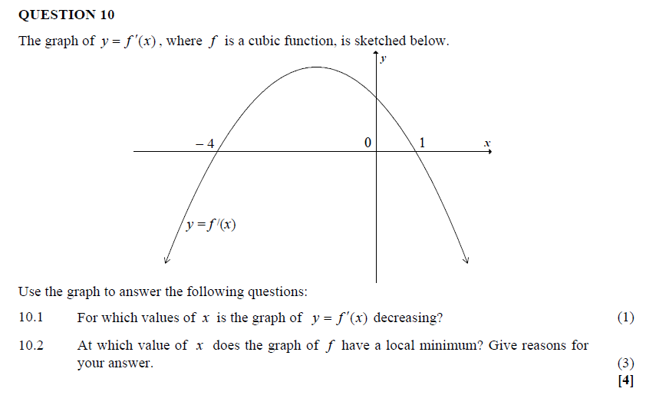

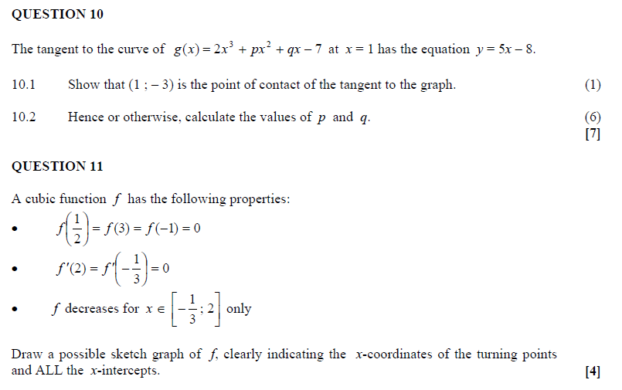**FEBRUARY/MARCH 2012**

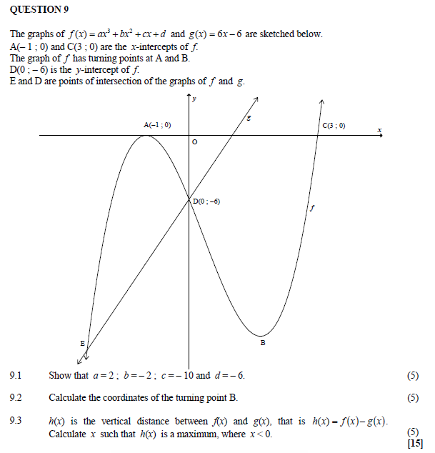

**NOVEMBER 2012**

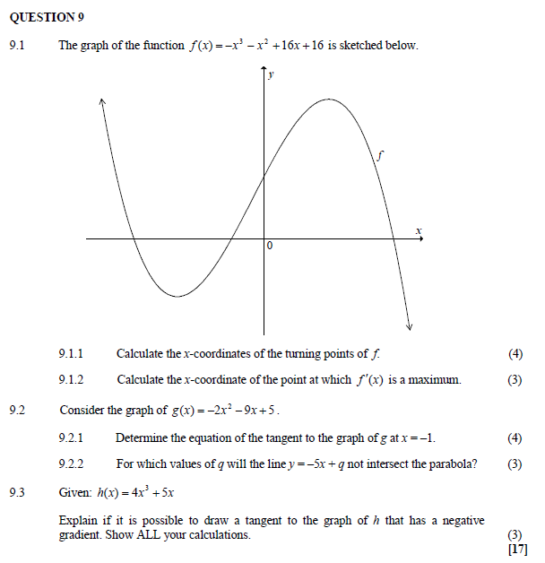

**MARCH 2013**

