**CALCULUS (BASICS)**

**NOVEMBER 2008**

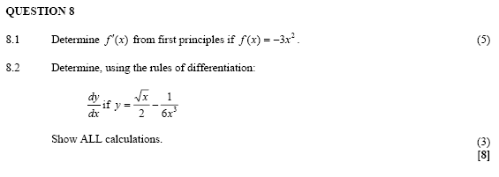

**FEB/MARCH 2009**

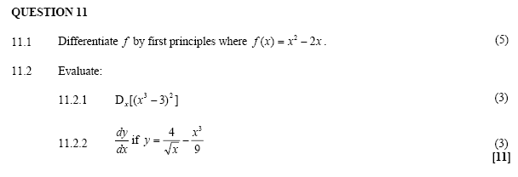

**NOVEMBER 2009**

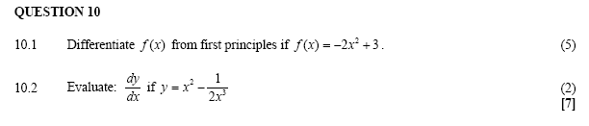

**FEB/MARCH 2010**

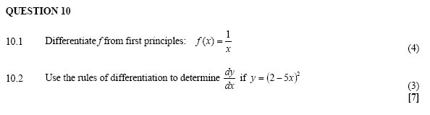

**NOVEMBER 2010**

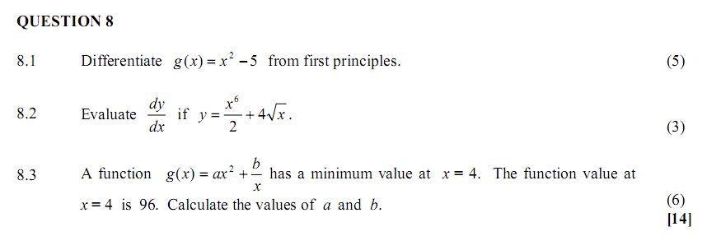

**FEB/MARCH 2011**

**QUESTION 9**

|  |  |  |  |
| --- | --- | --- | --- |
| 9.1 | Use the definition to differentiate . (Use first principles.) |  | (4) |

|  |  |  |  |
| --- | --- | --- | --- |
| 9.2 | Calculate . |  | (3) |

|  |  |  |  |
| --- | --- | --- | --- |
| 9.3 | Determine  if . |  | (3)  **[10]** |

**NOVEMBER 2011**

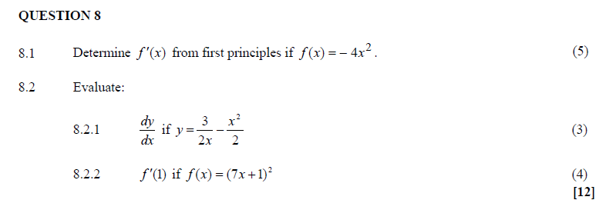

**FEB/MARCH 2012**

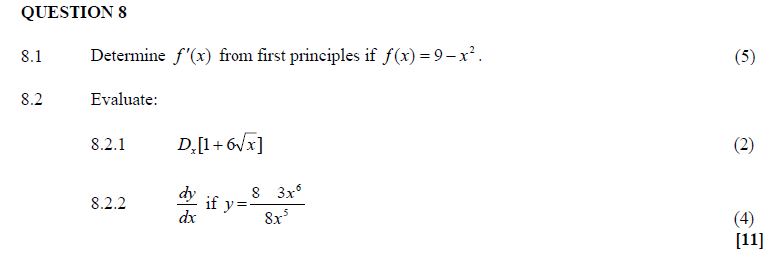

**NOVEMBER 2012**

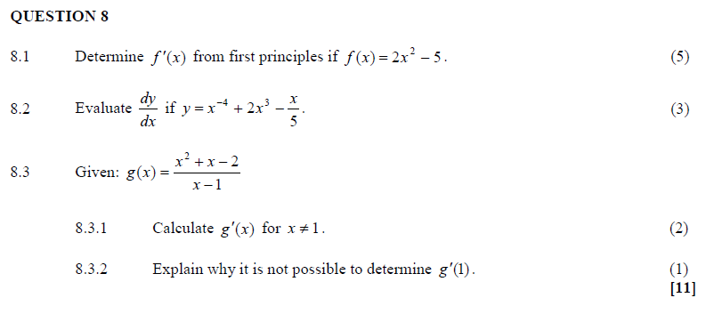

**MARCH 2013**

