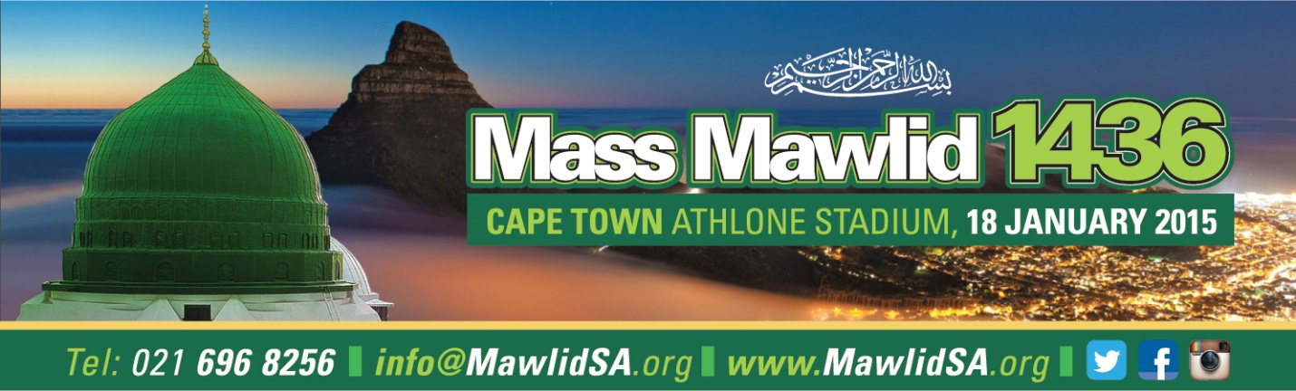
MAWLIDSA 1436 PROGRAM
18 JANUARY 2015
*****************************************************************************1
16h00 – 16h10 MC Welcome
Shaykh Abdurahmaan Alexander/Shaykh Fakhruddin Owaisi

16h10 – 16h20 Qira ah – Quarie Tahir Levy/Quarie Qaaed Davids

16h20 Asr Athaan – Moulana Ahmed Tahier Mohamed
16h30 Asr Salaah (Imam – Shaykh Afeefuddin Al Jailani) foll by Zikr
16h45 – 17h00 La Illaha illallaah (Hf Yusuf Khan + Sidi Safdar Aswatul Madina)
17h00 – 17h20 1st Riwayat Barzanji Led by Azzawiyyah plus Men/Women Mawlid Jamaahs (collectively)
17h20 – 17h35 Welcome (MawlidSA + CCT)15 minutes(Nabewiyya and Mayor)
17h35 – 17h50 Qasida Group(Ijaaz)
17h50 – 18h10 Lecture Shaykh Babikir Ahmed Babikir (20 Mins)

18h10 – 19h00 Qasida Burdah – Ba Alawi Group
MC MC handover from Shaykh Alexander to Shaykh Fakhruddin
19h05 – 19h25 Sh Afeefuddin Al Jailani (20 mins)
19h25 – 19h50 2nd/3rd Riwayat Barzanji by Azzawia and Mawlid Jamaahs
19h40 – 20h00 Naseehah by the Haakim of Cape Town(Shaykh Seraj Hendricks)
AFTER MAGHRIB PROGRAMME

20h02 - Athaan – Shaykh Faizel Firfery
Salaah – Shaykh Muhammad Moerat
20h20 - 20h35 Qasidah(Anwarul Madina) – Immediately after Salaah

20h35 – 21h00 Sh Muhammad bin Yahya al Ninowy - Shama’il

21h00 – 21h10 Mawlid Special Remarks (Shaykh Bin Omar)

21h10 – 21h15 Vote of Thanks: Hafith Mahmood Khatib
21h15 4th Riwayat Barzanji and Ashraqal led by Azzawiya
And all Mawlid Jamnaahs

CLOSING DUA AND ESHA SALAAH IN JAMAAH

