______________________________________________________________________________________________________
2 Queens Park Avenue
SALT RIVER
7925

P O Box 16210
Vlaeberg 8018

Tel: (021) 442 3500
Fax: (021) 447 7271
Email: info@vocfm.co.za

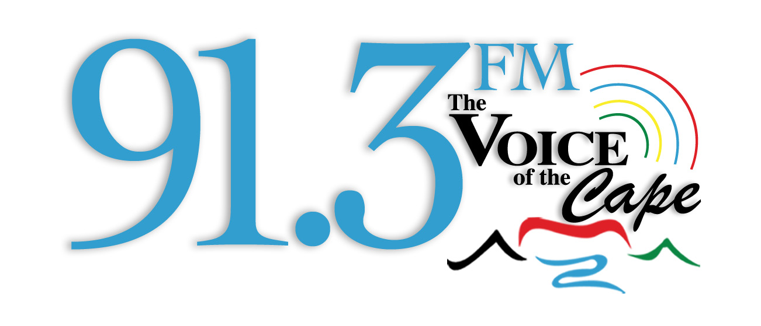
My Radio Station, Your Radio Station, Our Radio

Who can enter?
The Ramadan Children quiz which started on Monday 29th June is aimed at children aged 10 years and older and in primary school. Parents are requested to enter the names of their children’s (10 years old , older and primary school) who are interested and simply SMS ( the word Quiz followed the Name of Child to the number 47913) . Participants selected will be invited to Kids Clubhouse on Afternoon Cruise between 14h00 and 15h00 on Monday, Tuesday, Thursday or Friday during the month of Ramadaan. The programme is hosted by Youth Hour presenter Jasmina Petersen.

How it will work on air:
The presenter will ask participants to select a card with the different Pillars Iman, Salaah, Zakaah, Fasting or Hajj. Based on the participant’s selection the presenter will randomly select questions from the list chosen and give each participant 2 minutes to answer as much questions correctly. The winner of the round will be entered into the draw and stand a chance of being selected for the final quiz on Eid Day.

The question has been extracted from the Five Pillars Board Game cost R350 and is available for purchase at Voice of the Cape office 2 Queens Park Avenue. For more information contact 021 442 3500 Monday to Friday during office hours

It’s going to be great fun

1st Pillar: Iman

- Fill in the blanks: Allah (SWT) says; ''Every soul shall taste_____.''
  - heaven
  - Death
  - Hell

- Prophet Muhammad (SAW) said that every action will be judged by its______.
  - actions
  - Intention
  - words

- How many articles of Iman are there?
  - ten
  - Six
  - one

- Which of the following is not an article of Iman?
  - Belief in the messengers
  - Belief in the angels
  - Belief in the afterlife
  - Belief in the inner demons

- What is the Arabic term for associating partners with Allah (SWT)
  - shaytaan
  - Shirk
  - Majnoon

- Who was the final messenger of Allah SWT
  - Prophet Muhammad SAW
  - Prophet Adam Alaysalaam
  - Prophet Ebrahim Alaysalaam

- Who was the first man created by Allah (SWT)?
  - Prophet Muhammad SAW
  - Prophet Adam Alaysalaam
  - Prophet Yunus Alaysalaam

- What is the name of Shaytan that is mentioned in the Qur'an?
  - Iblis
  - Jinn
  - Malaikat

- What does Tawhid mean?
  - Belief heaven and hell exist
  - Belief in the oneness of Allah (SWT)
  - Belief in the quran

- What is the greatest sin?
  - Back bite
  - Shirk
  - Lie

- Which Angel is incharge of revelation?
  - Gibreel
  - Mika-eel
  - Munkar and Nakir

- What was the name of Adam's (ALSM) wife?
  - Ghouwa
  - Mariam
  - Souda

- What must a non-muslim do to become a Muslim?
  - Fast the month of Ramadaan
  - Recite the Shahadah
  - Drink Zam Zam

- Fill in the blank:Prophet Muhammad SAW said; ''_______ is built upon five pillars.''
  - Family
  - Islam
  - Friends
- To which prophet was the Torah revealed?
  - Prophet Muhammad SAW
  - Prophet Musa Alaysalaam
  - Prophet Esha Alaysalaam

- To which prophet was the Zabur revealed?
  - Yusuf AS
  - Dawud AS
  - Ismail AS

- To which prophet was the Injil revealed?
  - Isa AS
  - Yusuf AS
  - Ismail AS

- Which of the following sins makes a person a disbeliever?
  - Worshipping an idol
  - Backbiting
  - Gambling
  - Drinking alcohol

- Which of the following is not the belief in the Afterlife?
  - Belief in Paradise
  - Belief in Hellfire
  - Belief in Jinn
  - Belief in the Day of Judgement

2nd Pillar - Salaah
- For whom is prayer/salaah in congregation highly recommended
- Children
- Men (some scholars say its compulsory)
- Men and women

- What is the name for the prayer after Eshaai which has an odd number of Rakáh
- Salaatul Layl
- sunnah
- Witr Salaah

- Which of the obligatory prayers has an odd number of Rakáh?
- Fajr
- maghrib
- Eshaa and Maghrib

- How many rakáh of emphasized Sunnah prayer are there before fajr
- One Rak’ah
- Two Rak’ah
- Three Rak’ah

- How many times is Surah Al Fatihah recited in the obligatory prayers each day
- 20 times
- 17 times
- 15 times

- Which obligatory prayers require silent recitation of the Quran
- Dhur and Asr
- Magrib and Eshaa
- Magrib

- What do Muslims face when performing Salaah
- The door
- The Ka’bah
- The floor

- What is the Arabic name for the call to prayer
- Bilal
- Adhan
- Iqamah

- What is the Arabic name for the call which announces that prayer is beginning
- Bilal
- Adhan
- Iqamah

- How many prostrations are there in a Rak’ah
- Eight prostrations
- Two prostrations
- Six prostrations

- Which of the following is not an obligatory part of Wudu
- Washing the face
- Washing the arms
- Wiping the head
- Rinsing the mouth

- When making Wudu a limb can be washed for a maximum of how many time
- Eight times
- Three times
- Six times

- What is the name for the prayer for the dead
- Salaah Al-Janazah
- Salat al-Hajah

- When performing Wudu is the face or arms washed first?
Answer: Face

- When performing Wudu is the arms washed before the head’s wiped?
Answer: Yes, arms are washed before wiping the head

- If there is no water, what can a person do to purity himself or herself for Salah?
Answer: Make Tayamum

- Complete the sentence; Prophet Muhammad SAWS said, ‘’Wudu is……. of salah’’?
Answer: Half Reference; Hadith: Sahih Muslim

3rd Pillar: Zakah

- Why do men inherit twice the share of women in some situations?
  - Because they have to care for and provide for those women
  - Because they stronger than women
  - Because they need to buy presents for the family
- Q: Which of the following people can never inherit from you?
  - Grandfather
  - Grandson
  - Cousin
  - Sister
- Q: In order to leave a portion of wealth to a non-heir what must a person do?
  - Make a bequest in his will
  - Make an public announcement
  - Write a letter to the non-heir
- Q: Which of the following cannot be given as pure charity?
  - Income
  - Savings
  - Gifts
  - Usury
- According to a saying of Prophet Muhammad (SAW) will the rich or poor Muslims enter paradise first?
  - The poor will enter first (reference: Hadith – Jami At-Timirdhi)
- Fill in the blanks: Prophet Muhammad (SAW) said “Every act of goodness is ………….”
  - Charity (reference: Hadith – Sahih Muslim)
  - Rewarded
  - Great

- How often is Zakah due?
  - Once a year
  - The entire year
  - Four time a year
- Is Sadaqah optional or obligatory?
Optional

- What is Zakah Al-Fitr?
  - The charity given on the day of Jumuah
  - The charity given on the day of ‘Eid Al-Fitr’
  - The charity given on the day of fasting
- Is Zakah Al-Fitr optional or obligatory?
  - Obligatory (reference: Hadith – Sahih Bukhari, Sahih Muslim)
- Is Zakah paid on a person’s income or savings?
  - Savings
- Fill in the blanks: Allah (SWT) says, “It is not righteousness unless you spend from that which you …….”
  - Love (reference: Quran – Surah Ali Imran 3:92)
  - Hate
- Q: From which two qualities does Zakah purify our hearts?
  - Miserliness and Greed
  - Hate and jealousy
- For how long must wealth be kept before one pays Zakah on it?
  - One year
- For a specific portion of wealth is Zakah paid annually or one time only?
  - Annually

- What is the literal meaning of the Arabic word Zakah?
  - Purification
  - Giving
- What is the wisdom behind giving the remainder of the deceased person’s inheritance to the closest male relative?
  - He has to provide for the rest of the family
  - He has to make charity and give to the poor
- What percentage of wealth must a person give up as Zakah?
  - 2.5%
  - 10 %

4th Pillar SAWM/ Fasting
- What do most Muslim communities try to accomplish in Tarawih every Ramadan?
- Recitation of the entire Quran
- To exercise and keep fit

- On which date in the Islamic calendar is the first Tarawih performed?
- 1st of Ramadan
- 2nd Shabaan

- On which of the following dates is it highly recommended to fast
- 4th of Safar
- 10th of Muharram
- 20th of Rajab
- 18th of Dhul Qa’dah

- Which of the following is permissible while fasting
- Eating
- Drinking
- Sleeping
- Smoking

- What is the missing word in the following sentence:Prophet Muhammad SAW said, ‘’When Ramadan begins, the gates of______ are opened.”
Answer: Jannah (Paradise) Hadith: Sahih Bukhari, Sahih Muslim

- What is the missing word in the following sentence: Prophet Muhammad SAW said, ‘’When Ramadan begins, the_____ are chained.”
Answer: Shayatain ( devils) Hadith: Sahih Bukhari, Sahih Muslim

- Is the first Tarawih prayed before or after the first fast
- After the first fast
- Before the first fast
- Before the last fast

- What is the recommended drink when breaking the fast?
  - Milk
  - Water
  - Milkshake

- Which of the following should be our intention when fasting?
  - To please you mom and dad
  - To please Allah SWA
  - To please your friends

- When fasting it is recommended to clean your teeth with what?
  - Toothpick
  - Tooth brush
  - A Miswak

- Which prayer can be prayed at the same time as the pre-dawn meal
  - Eshaa
  - Tahajud( the night prayer)
  - Witr

- What is the recommended food to eat when breaking the fast
  - Apple
  - Date
  - Soup

- Which ‘’Eid is celebrated the day after the month of Ramadan ends
  - Eid Al Fitr
  - Eid Al Adha

- What signals the start and end of the month of Ramadaan
  - The sighting of the stars
  - The sighting of the new moon ( crescent)

- How many days can there be in the month of Ramadaan
  - 29 or 30 days
  - 30 or 31 days

- What time of the day does fast end
  - 5pm
  - Sunset
  - 7pm

- What time of the day does the fast begin
  - Break of dawn
  - Midday
  - After eshaa

5th Pillar: HAJJ
- How many Days does a person stay in Ihraam
  - Three Days
  - Two day

- What is the name of the Minor Pilgrimage in Islam?
  - Holiday
  - Umrah

- What is the name of the house of Allah in Makka?
  - The Ka’bah
  - Palace

- How many times does one have to go round in the Ka’bah when performing tawaaf?
  - Three times
  - Seven Rounds

- How many Jamarat are there?
  - Three
  - Millions
- What is the name of the famous well in Makkah from which pilgrims drink?
  - well of Zam Zam
  - well of Makkah

- How many times did prophet Mohammd (Saw) Perform Hajj?
  - Once
  - Million times

- What should the pilgrim say when throwing a pebble at the Jamarat?
  - Allahu Akbar( Allah is the greatest)
  - Biesmillah
9. Where do the pilgrims gather to start their Hajj?
Answer: Mina

10. In which of the following cases is hajj obligatory?
- Every year
- Once in a lifetime
- Once every ten years
- Every time you can afford it

11. How many Pieces of Cloth make up the ihram for men?
Answer: Two

12. Which prophet was told to give the first call for hajj?
Answer: prophet Ibrahim (A.s)

13. Who helped prophet Ibrahim (A.s) build the Kab’ah
Answer: His son Ismail ( A.s)

14. At which mount should a person begin sa’I ?
Answer: Mount Safa

15. Where is the mount of mercy located?
Answer: Arafah

16. Where do the pilgrims gather to start their pilgrims?

Answer: Mina
17. What is the name of the stone on the Ka’bah?
Answer: Hajar Al Aswad( the Black Stone)

